P.O Box 1173, Camp Hill, PA 17011

February 10, 2019

To Whom It May Concern:

I am proud to announce that the 15th Annual Randi’s Race: A 5K Run/Walk for Hope and Courage is scheduled for Saturday, May 11, 2019, at Adams Ricci Community Park in Enola. I am calling upon the generous support of businesses across central Pennsylvania to once again help make this event a success.

The tragedy of my daughter’s death and the work that I have done to speak out against domestic violence has given me hope for the future. In addition to Randi’s Race, I have established Randi’s House of Angels (RHOA), a project of The Foundation for Enhancing Communities. This project will help fulfill my dream of supporting and providing services for children who experience and/or are victims of domestic violence.

Because of the substantial support of the community over the past fourteen years, Randi’s Race has raised more than $423,000 to benefit Randi’s House of Angels. Over $275,000 has been donated to domestic violence and crime victim agencies that support programs for children. More importantly, RHOA maintains therapeutic programs, including Randi’s Kidz Club, a ten-week therapeutic group for children ages 8-13; Randi’s Camp, a three-day interactive summer camp; and Randi’s Klubhouse, an interactive therapeutic group for children 5-7. To date more than 100 children have received services through RHOA.

David J. Freed, Esquire, who serves as our honorary chair, continues to support and promote the event, along with several other officials. Your support will allow Randi’s Race to experience another successful year. Please find an enclosed list of sponsorship opportunities. Sponsors will receive the Randi's Race logo and poster for websites and display at your business.

Thank you for your consideration. If you have any questions, please contact me directly at (717) 503-4498 or email me at njchavez@verizon.net.

Sincerely,
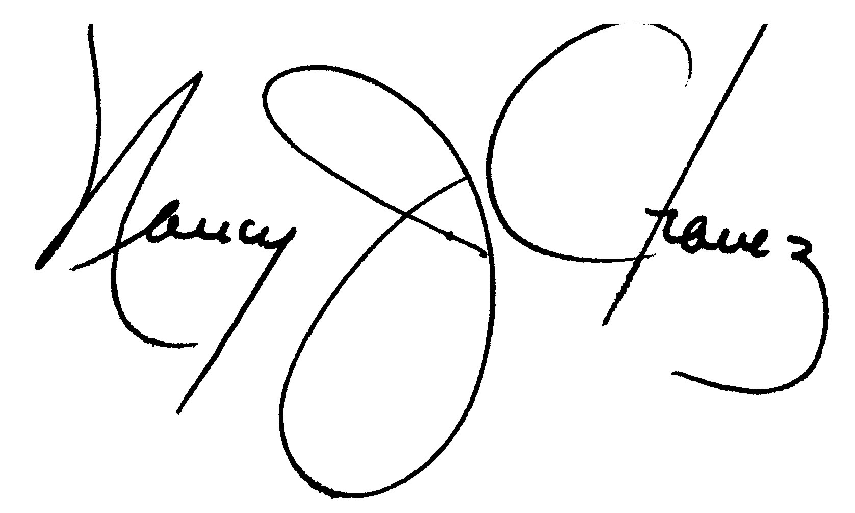
Nancy J. Chavez, Chairperson

Randi’s House of Angels is a project of The Foundation for Enhancing Communities, fiscal sponsor. The official registration and financial information of The Foundation for Enhancing Communities may be obtained from the Pennsylvania Department of State by calling toll free, within Pennsylvania, 1.800.732.0999. Registration does not imply endorsement.
Sponsor Registration

Sponsorship Levels:
Sponsors will be included on all marketing materials; posters, radio, TV and local advertisements. Sponsors will also electronically receive Randi's Race promotional materials, logo and poster.

 | Premier Sponsor $5,000  Diamond Sponsor $3,500 | Company name on all mile markers, posters, marketing material, media, local advertisements, agency website, banner display and premier location on T-shirt.  Company name on all mile markers, posters, marketing material, media, local advertisements, agency website and premier location on T-shirt.
 | Platinum Sponsor $2,500 | Company name on all posters, marketing material, media, local advertisements, agency website and top back of T-shirt.
 | Gold Sponsor $1,000 | Company name on all posters, marketing material, media, local advertisements, agency website and middle back of T-shirt.
 | Silver Sponsor $500 | Company name on all posters, marketing material, media, local advertisements, agency website and lower back of T-shirt.
 | Bronze Sponsor $250 | Company name on all posters, marketing material, media, local advertisements, agency website and lower back of T-shirt.

Publicity
Please check here if you prefer to remain anonymous.

Company Logo
Email Nancy Chavez at njchavez@verizon.net for the t-shirt design. Please forward a jpeg file no later than Friday, April 19, 2019.

Contact Information – please print
Contact Name:
Business Name:
Mailing Address:
City: |  |  |  |  |  |  | State: |  |  | Zip:
Work Phone: |  |  |  |  |  | Email:

Checks: The Randi’s House of Angels is a project of The Foundation for Enhancing Communities, fiscal sponsor. Make checks payable to Foundation of Enhancing Communities - write “Sponsor Randi’s Race 2019” on the memo line and mail to 200 North 3rd Street, 8th Floor, Harrisburg, PA 17101.

