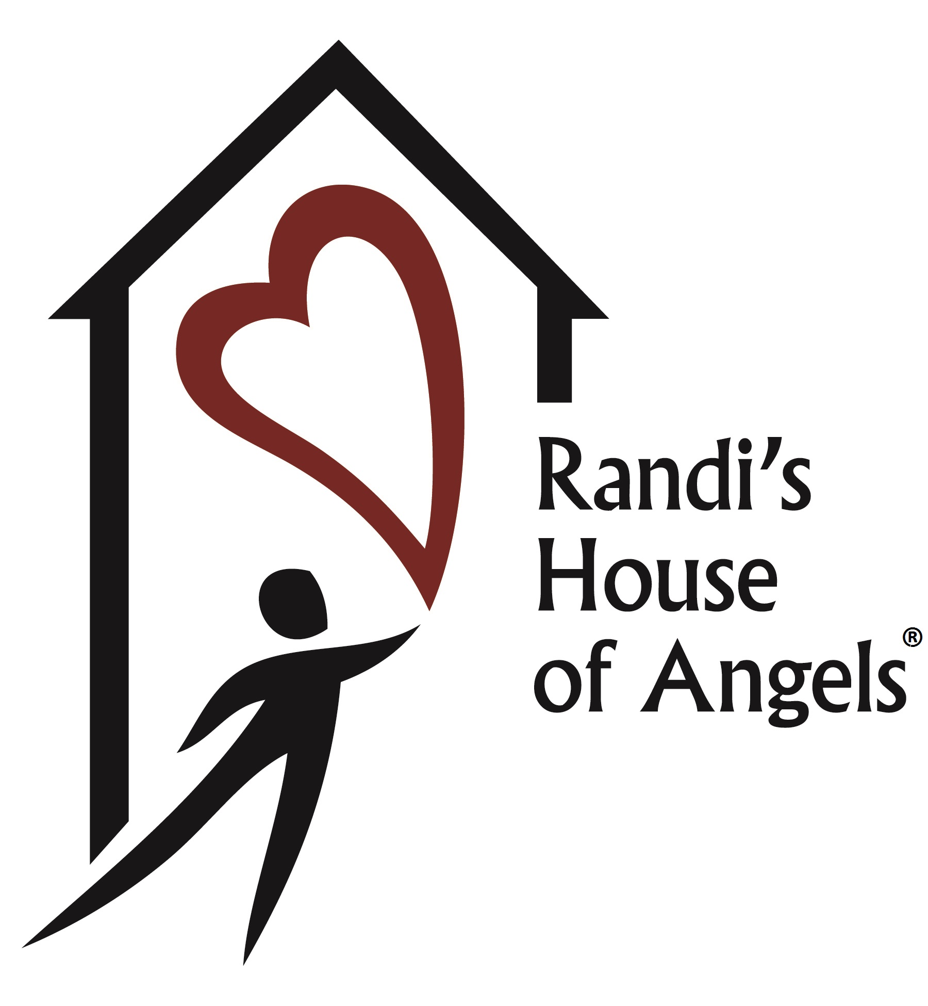 P.O Box 1173, Camp Hill, PA 17011

June 28, 2018

Dear Business Partner:

I am proud to announce our 3rd Annual A Round Fore Randi golf outing hosted by Randi’s House of Angels on Friday, September 7, 2018 at Rich Valley Golf Course.

I am calling upon the generous support of businesses across central Pennsylvania to sponsor the event. In recognition of your sponsorship your name and logo will be on our golf brochure, signage at the event and recognition in our golf program booklet.

Because of the generous support from the community, last year we raised over $9,000. Funds raised support Randi’s House of Angels programs for children that are victims of domestic violence including, Randi’s KIDz Club, a ten-week therapeutic group for children; and Randi’s Camp, a three -day interactive summer camp. To date we have helped over 100 children. Please take a minute to visit our website at www.randishouseofangels.org.

Your support will help to make our golf outing a success. Please find the attached list of sponsorship opportunities. If you have any questions, please contact me personally at
(717) 503-4498 or email at njchavez@verizon.net. Thank you for your consideration.

Sincerely,

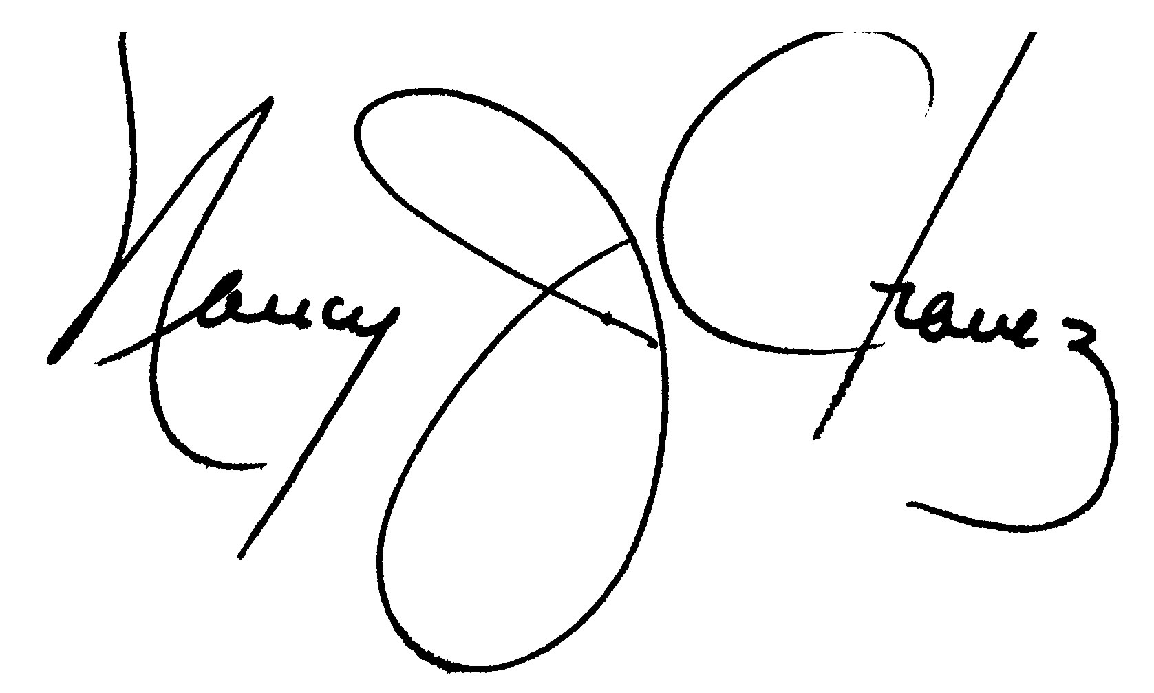
Nancy J. Chavez, Chairperson

Randi’s House of Angels is a project of The Foundation for Enhancing Communities, fiscal sponsor. The official registration and financial information of The Foundation for Enhancing Communities may be obtained from the Pennsylvania Department of State by calling toll free, within Pennsylvania, 1.800.732.0999. Registration does not imply endorsement.
Sponsor Registration

Sponsorship Levels: Sponsors will be included on all Randi’s House of Angels Website

 | Platinum Sponsor $650  Gold Sponsor $475 | Golf package for four plus banner with company logo displayed at the event.  Golf package for four plus banner with company logo displayed at the midway point on the course.
 | Hole Sponsor $100 | Signage on the tee with company logo.

Publicity
Please check here if you prefer to remain anonymous.

Company Logo
Email Nancy Chavez at njchavez@verizon.net for the signage and program. Please forward a high-resolution logo by Friday, August 17, 2018.

Contact Information – please print
Contact Name:
Business Name:
Mailing Address:
City: |  |  |  |  |  |  | State: |  |  | Zip:
Work Phone: |  |  |  |  |  | Email:

Checks: The Randi’s House of Angels is a project of The Foundation for Enhancing Communities, fiscal sponsor. Make checks payable to Foundation of Enhancing Communities - write “Sponsor A Round Fore Randi 2018” on the memo line and mail to 200 North 3rd Street, 8th Floor, Harrisburg, PA 17101.

